Instruction to set up the Sonar Cloud.

1.Create the account for Sonar Cloud in <https://sonarcloud.io/> by using Git hub

2.Create an organization in Sonar cloud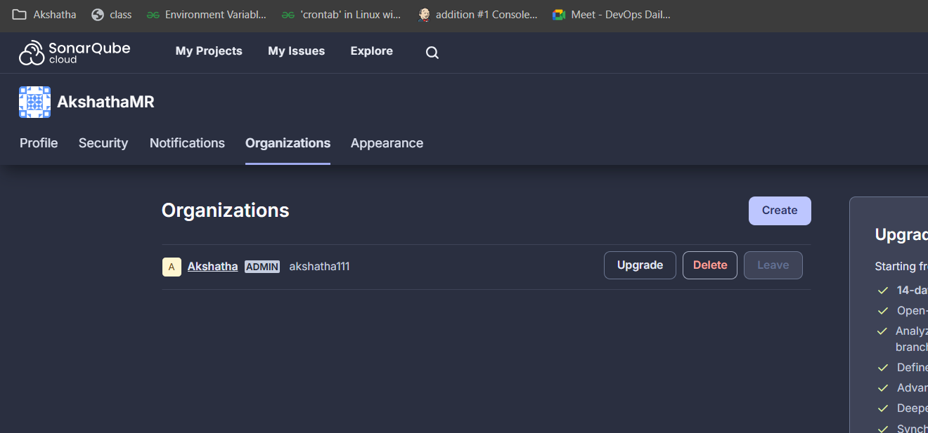

3.Generate a Sonar Cloud Token

Navigate to My Account > Security on Sonar Cloud.

Click Generate Tokens.

Provide a name for the token (e.g., JenkinsToken) and click Generate.

Copy the token and save it securely (you’ll use it in Jenkins). 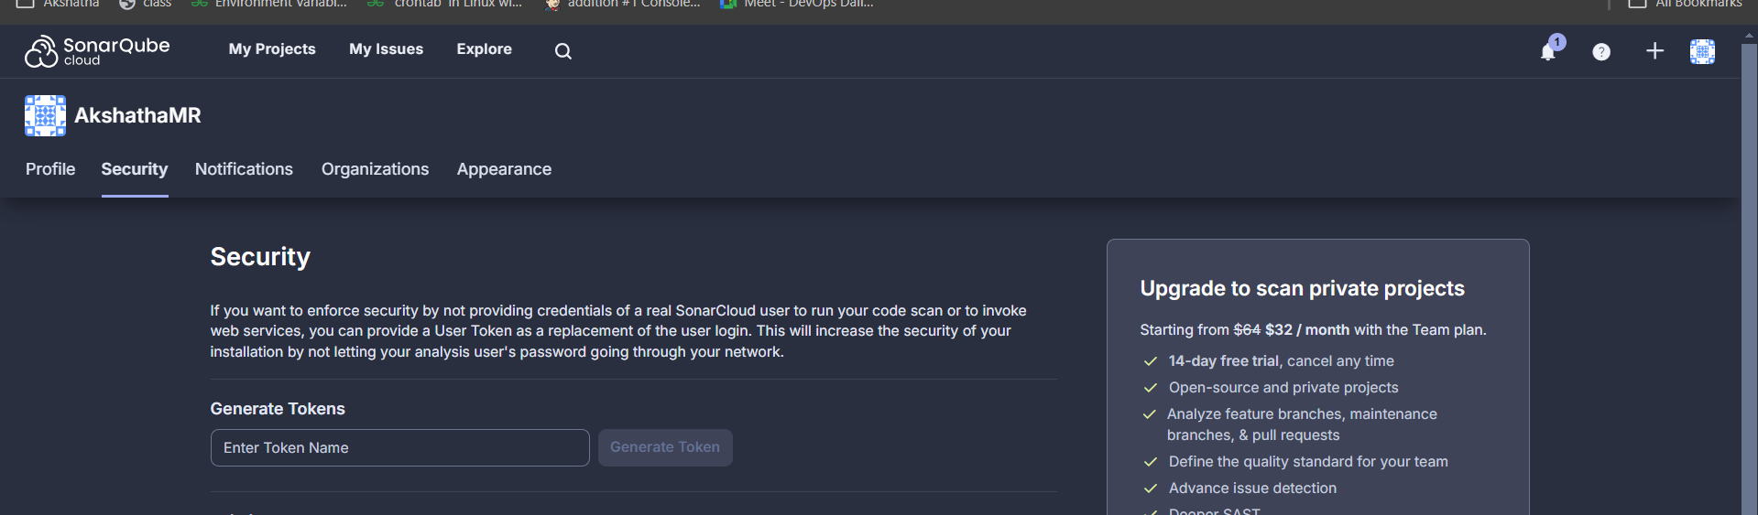

4.Install Required Plugins in Jenkins

Log in to Jenkins as an administrator.

Go to Manage Jenkins > Manage Plugins.

Under the Available tab, search for and install the following plugins:

SonarQube Scanner for Jenkins.

Pipeline Utility Steps (for pipeline jobs).

5. Configure Sonar Cloud in Jenkins

5.1. Add SonarCloud Token to Jenkins

Go to Manage Jenkins > Manage Credentials.

Add a new credential for your SonarCloud token:

Scope: Global

Kind: Secret text

Secret: Paste your SonarCloud token.

ID: Give it an ID, like sonarcloud-token.

5.2. Configure SonarCloud Server

Go to Manage Jenkins > Configure System.

Scroll to the SonarQube servers section.

Click Add SonarQube and configure:

Name: SonarCloud

Server URL: https://sonarcloud.io

Server Authentication Token:

Click Add > Jenkins Credentials and select the token created in step 3.1.

Save the configuration.

6. Configure SonarQube Scanner

Go to Manage Jenkins > Global Tool Configuration.

Under SonarQube Scanner, click Add SonarQube Scanner.

Configure the scanner:

Name: SonarScanner

Let Jenkins install it automatically (default settings).

Save the configuration.

7.Create the Project:

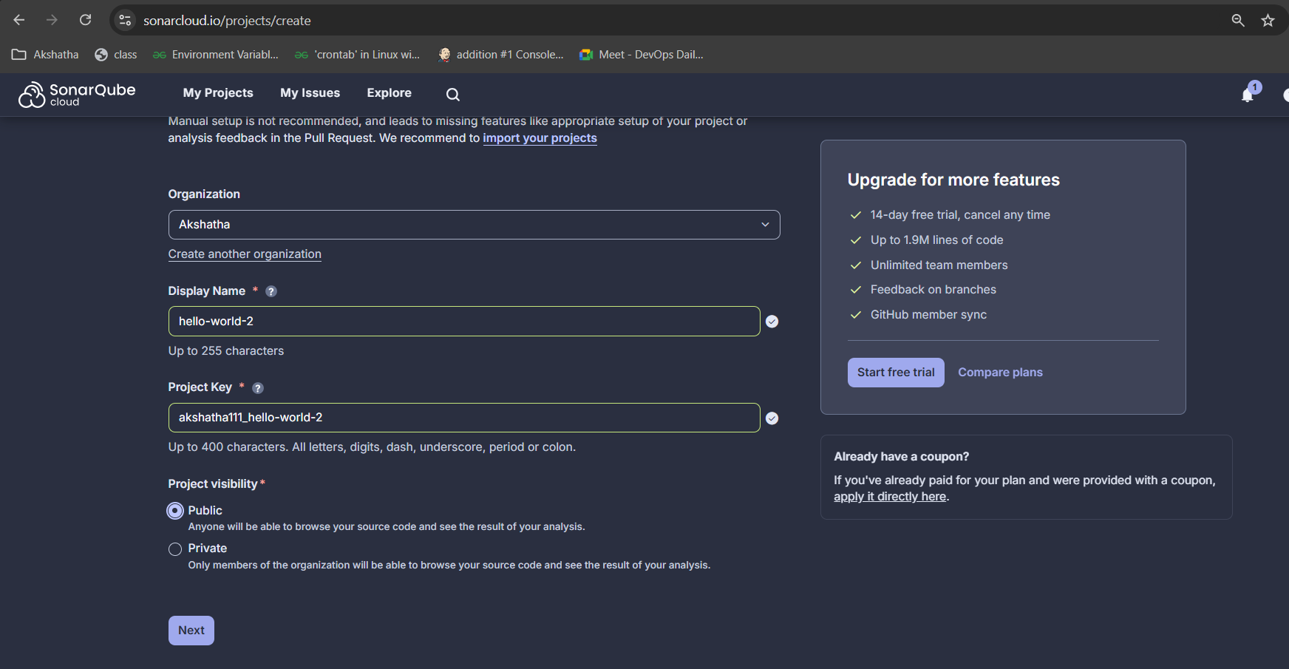

Select the Previous version

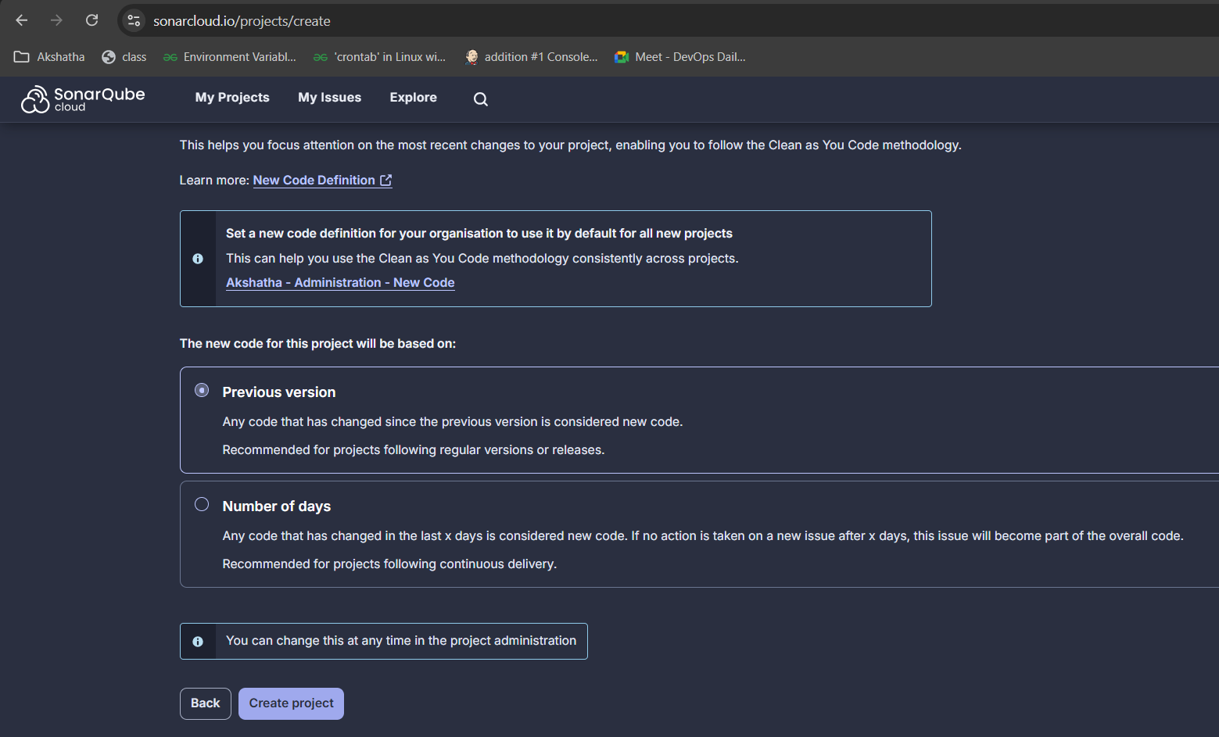

Select Manually here

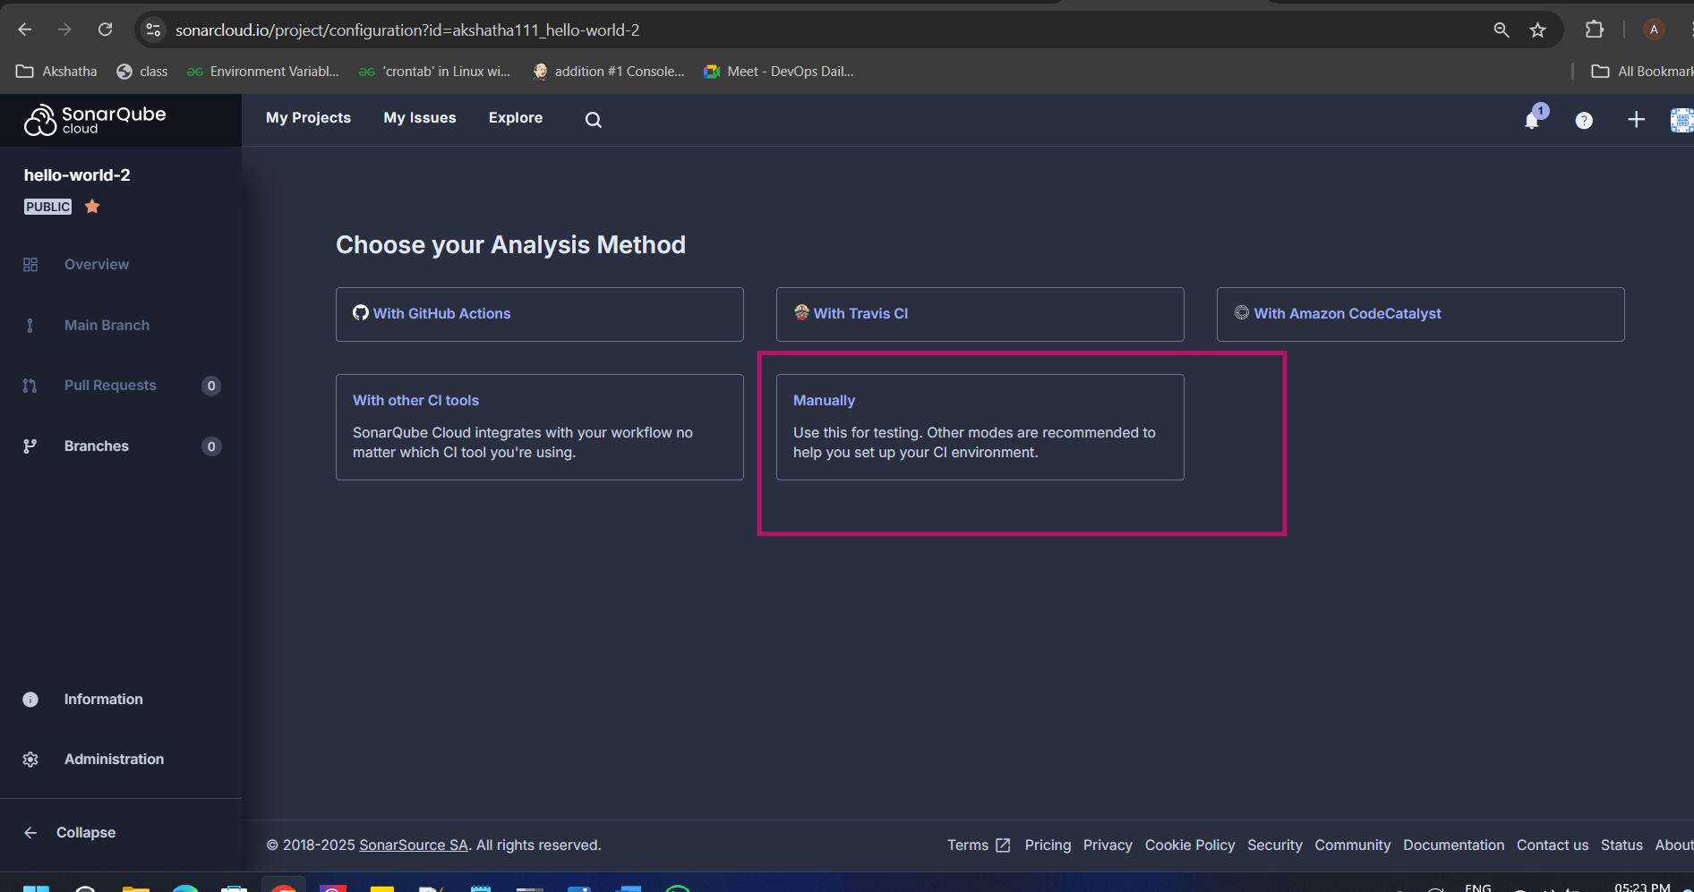

8.Add this value in credentials:

1. Name of the environment variable:
2. Value of the environment variable:
3. **Execute the SonarScanner for Maven from your computer**
4. Update your pom.xml file with the following properties:

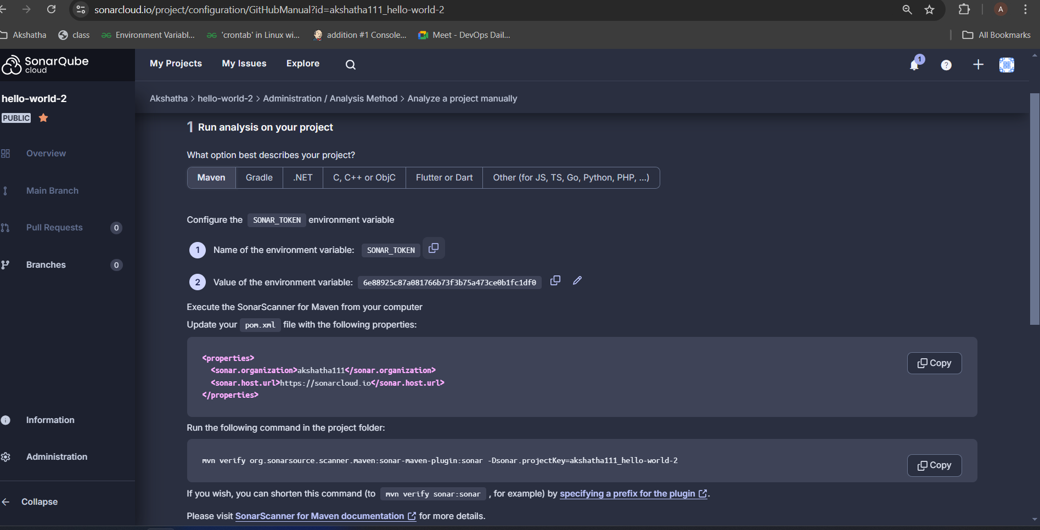

Add credentials under Manage Jenkins->Credentials tab by clicking on global create a new credentials in Jenkins

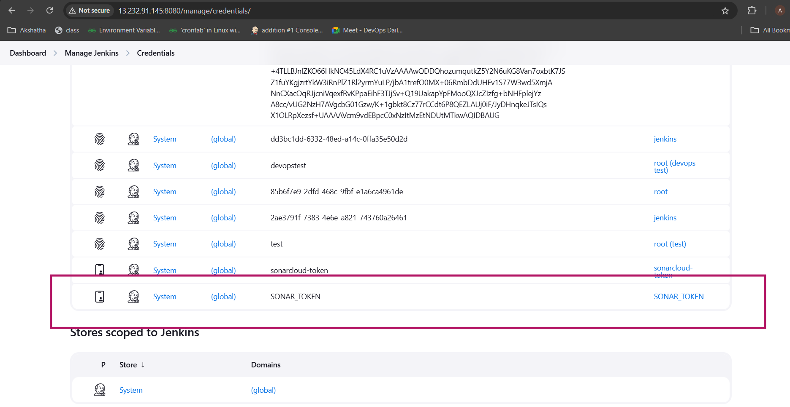

9. Add the sonar dependency and update the Jenkins file

Update the Jenkins file in Project folder with below code:

https://github.com/AkshathaMR/hello-world-war/blob/master/Jenkinsfile

update the pom.xml with below code link:

<https://github.com/AkshathaMR/hello-world-war/blob/master/pom.xml>

Create the Pipeline job in Jenkins

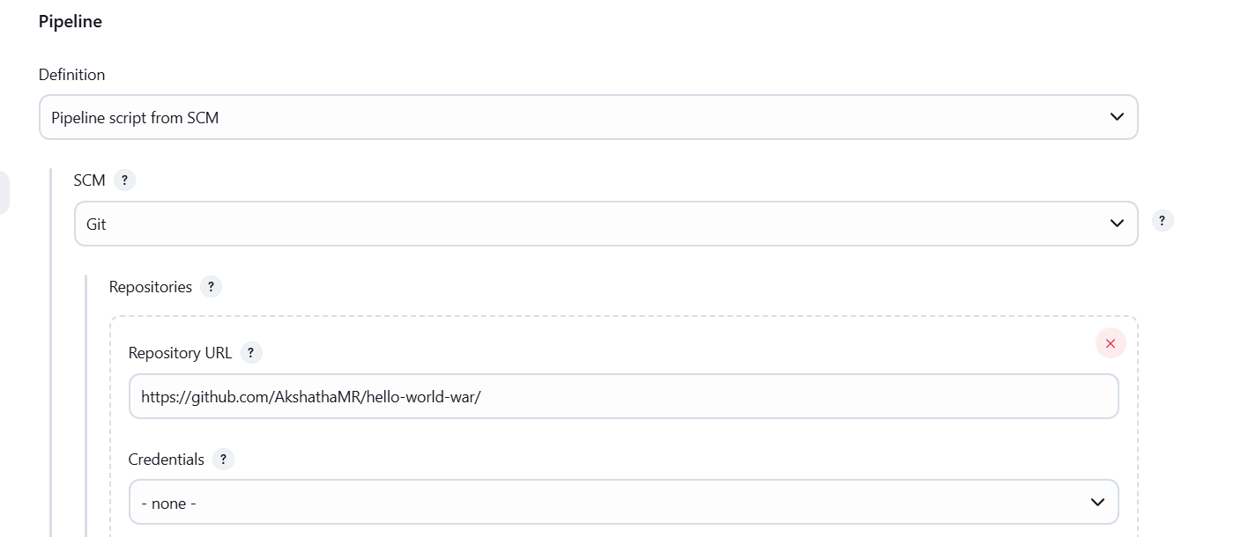

Output:

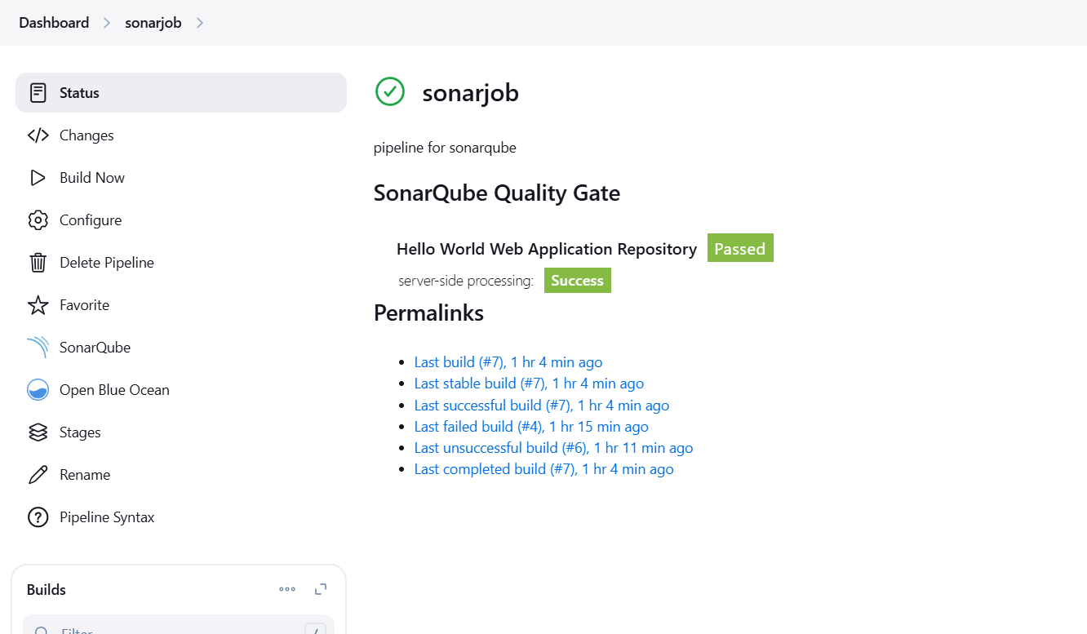

Sonar cloud project status:

